**Amazon Cloud front (CDN)**

Cloud Front CDN (Content Delivery Network) is a system of distributed servers that deliver web pages and other web content to a user based on the geographic locations of the user, the origin of the webpage and a content delivery server.

Cloud front (CDN) is optimized to work with other AWS services. Such as S3, EC2, Load balancer and Route 53.

**How does cloud front work with S3**

Go to the s3 service dashboard

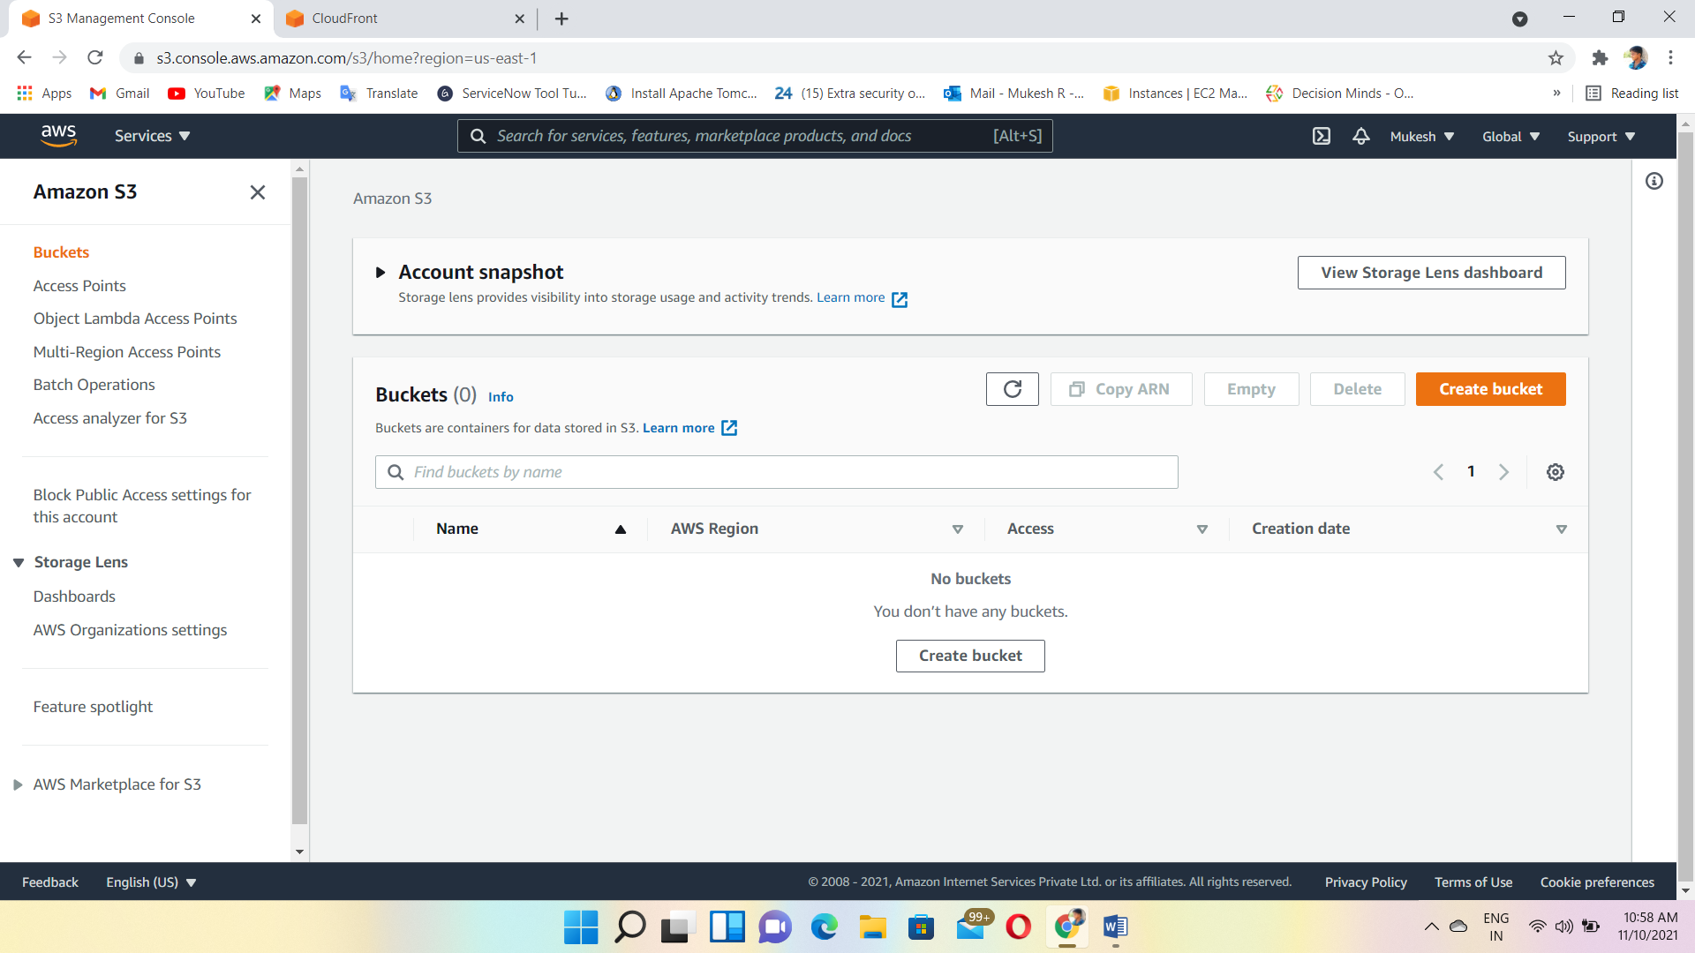

Create a bucket with globally unique name

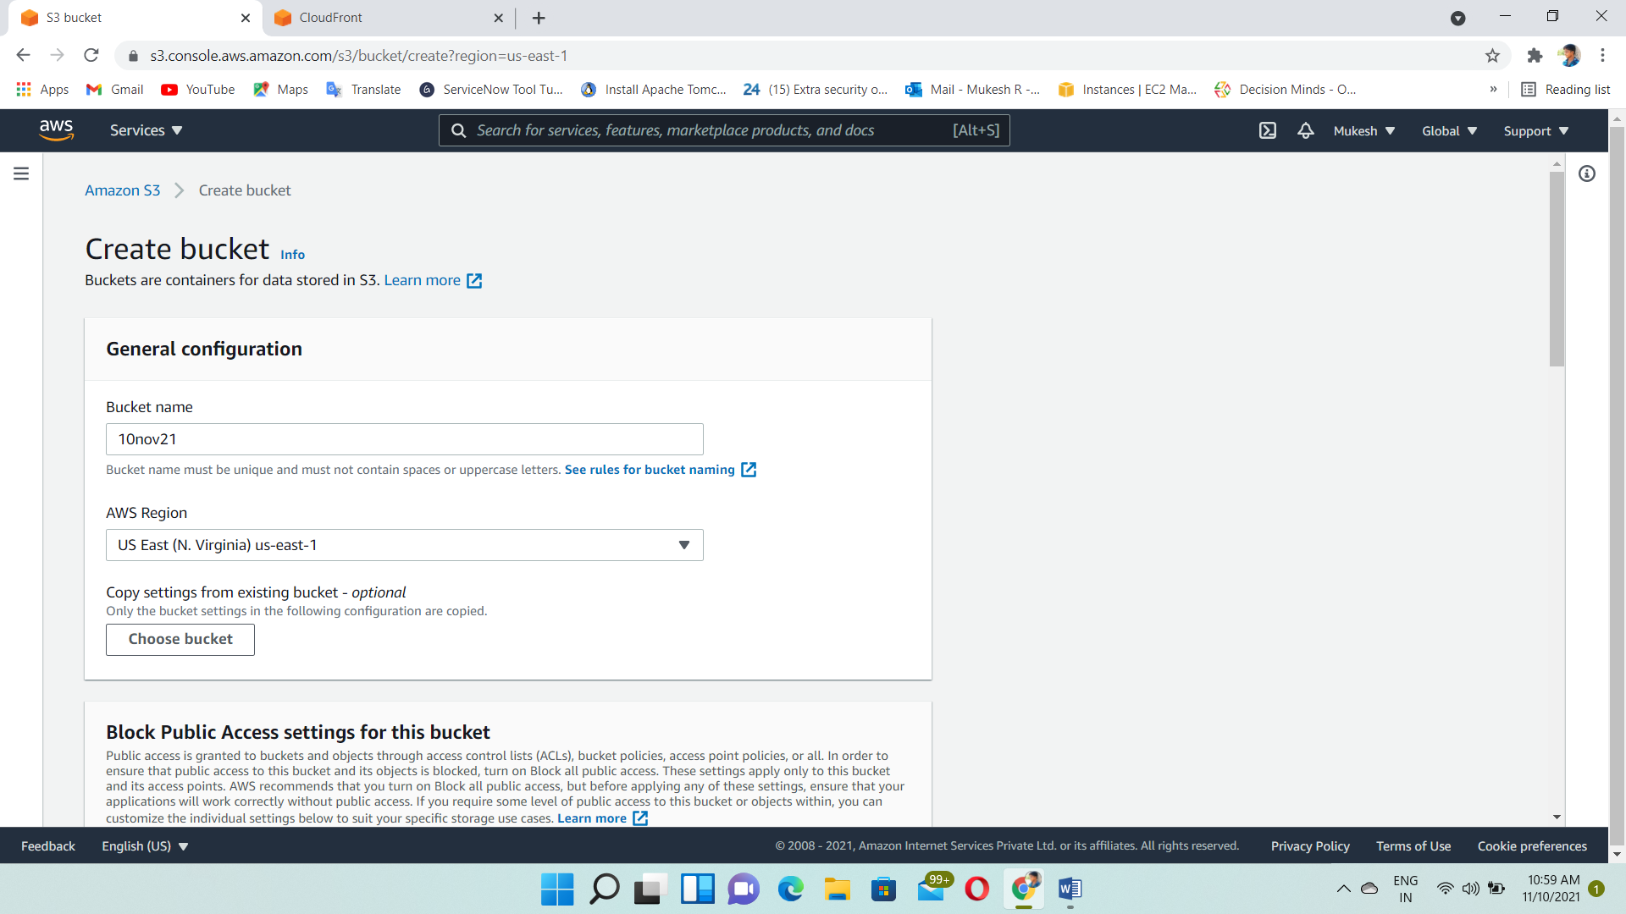

Allow the Public access while we creating the bucket

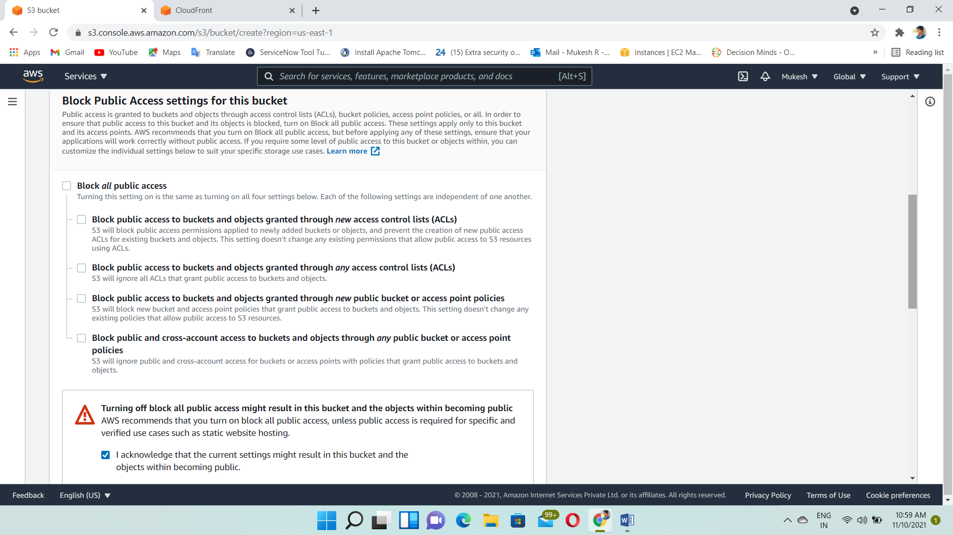

Creating Bucket

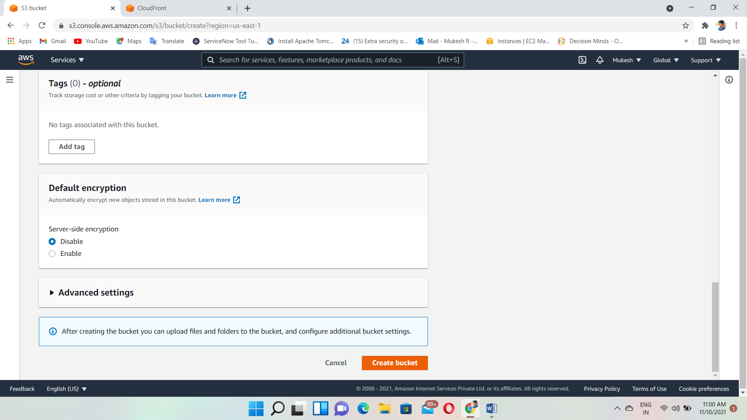

Set the permission for viewing files in the bucket to public

Generate the bucket policy

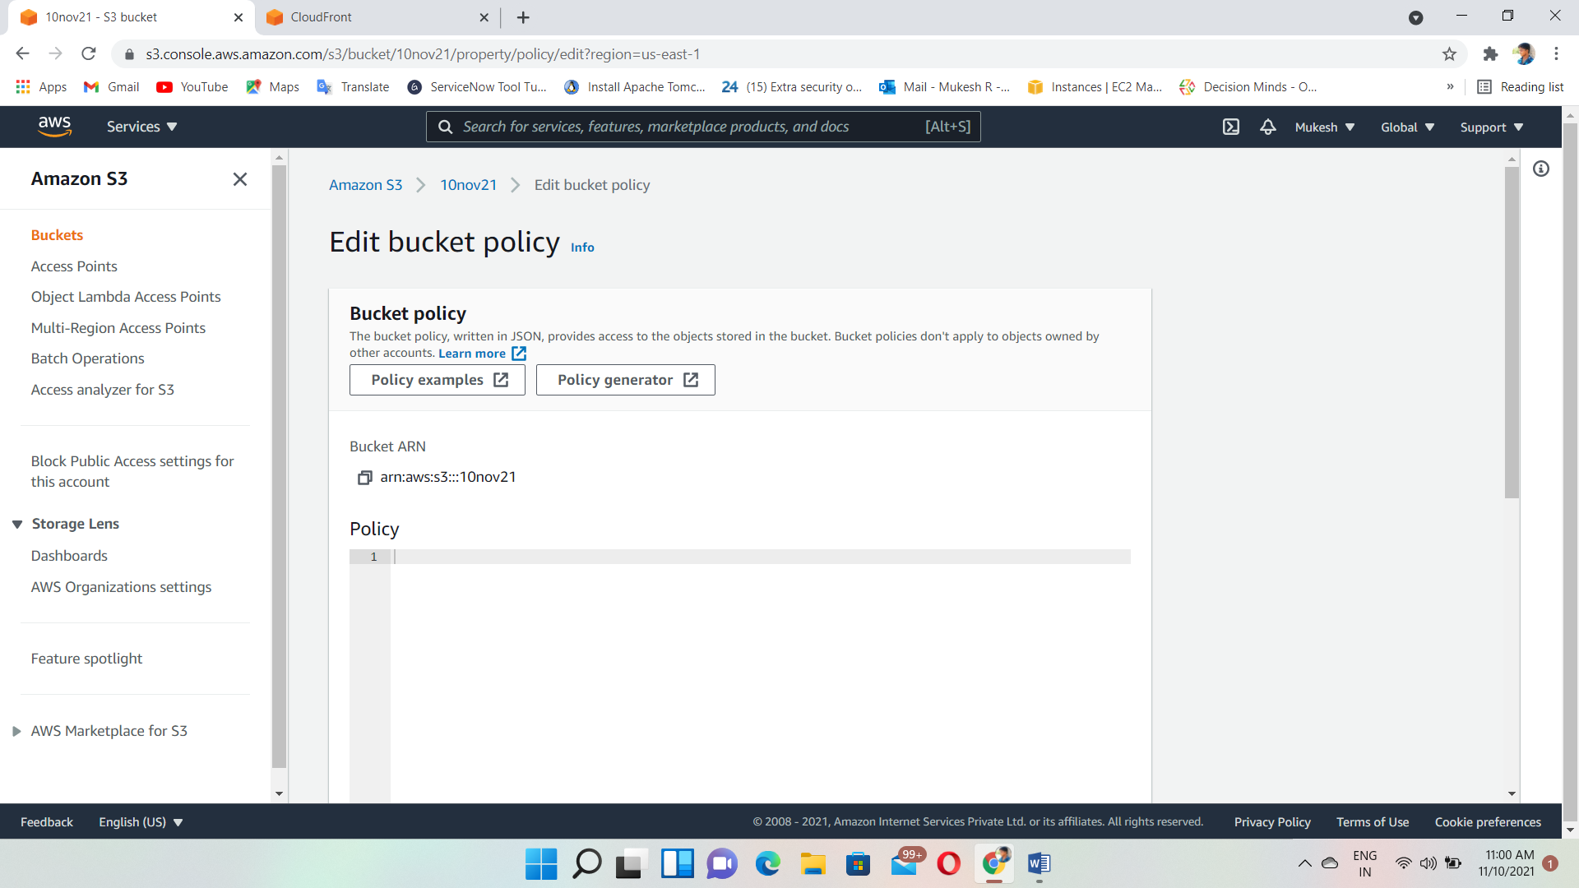

Give “get object” and “get object version” permissions

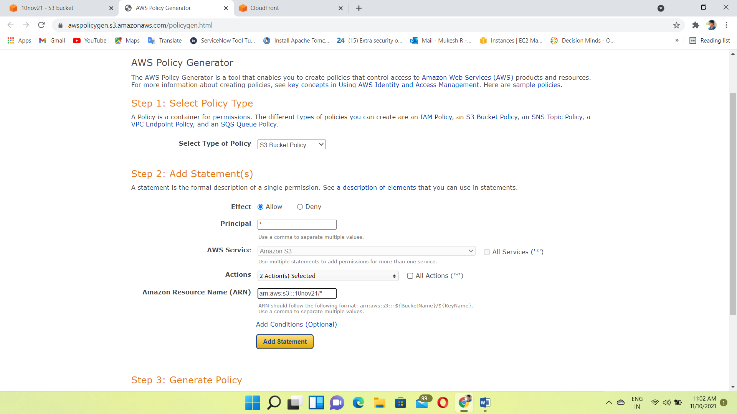

Copy that policy

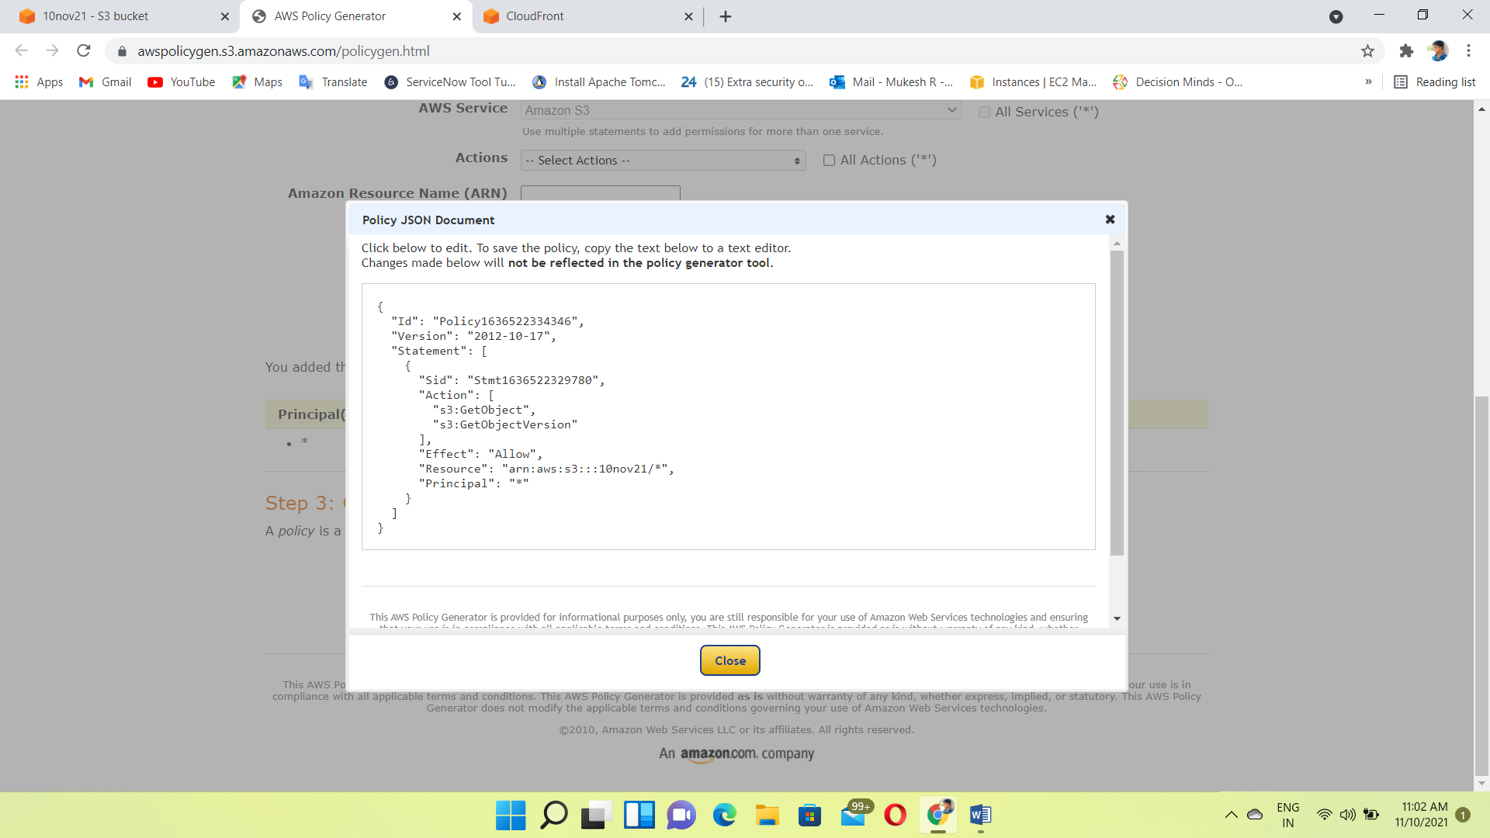

Paste it

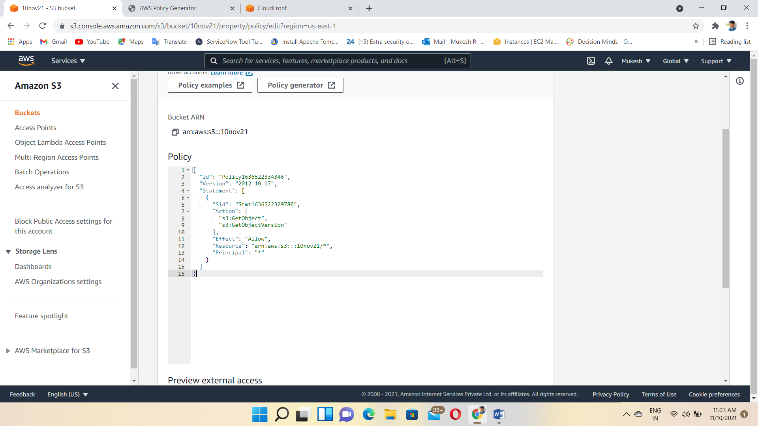

Uploading the html file inside the bucket

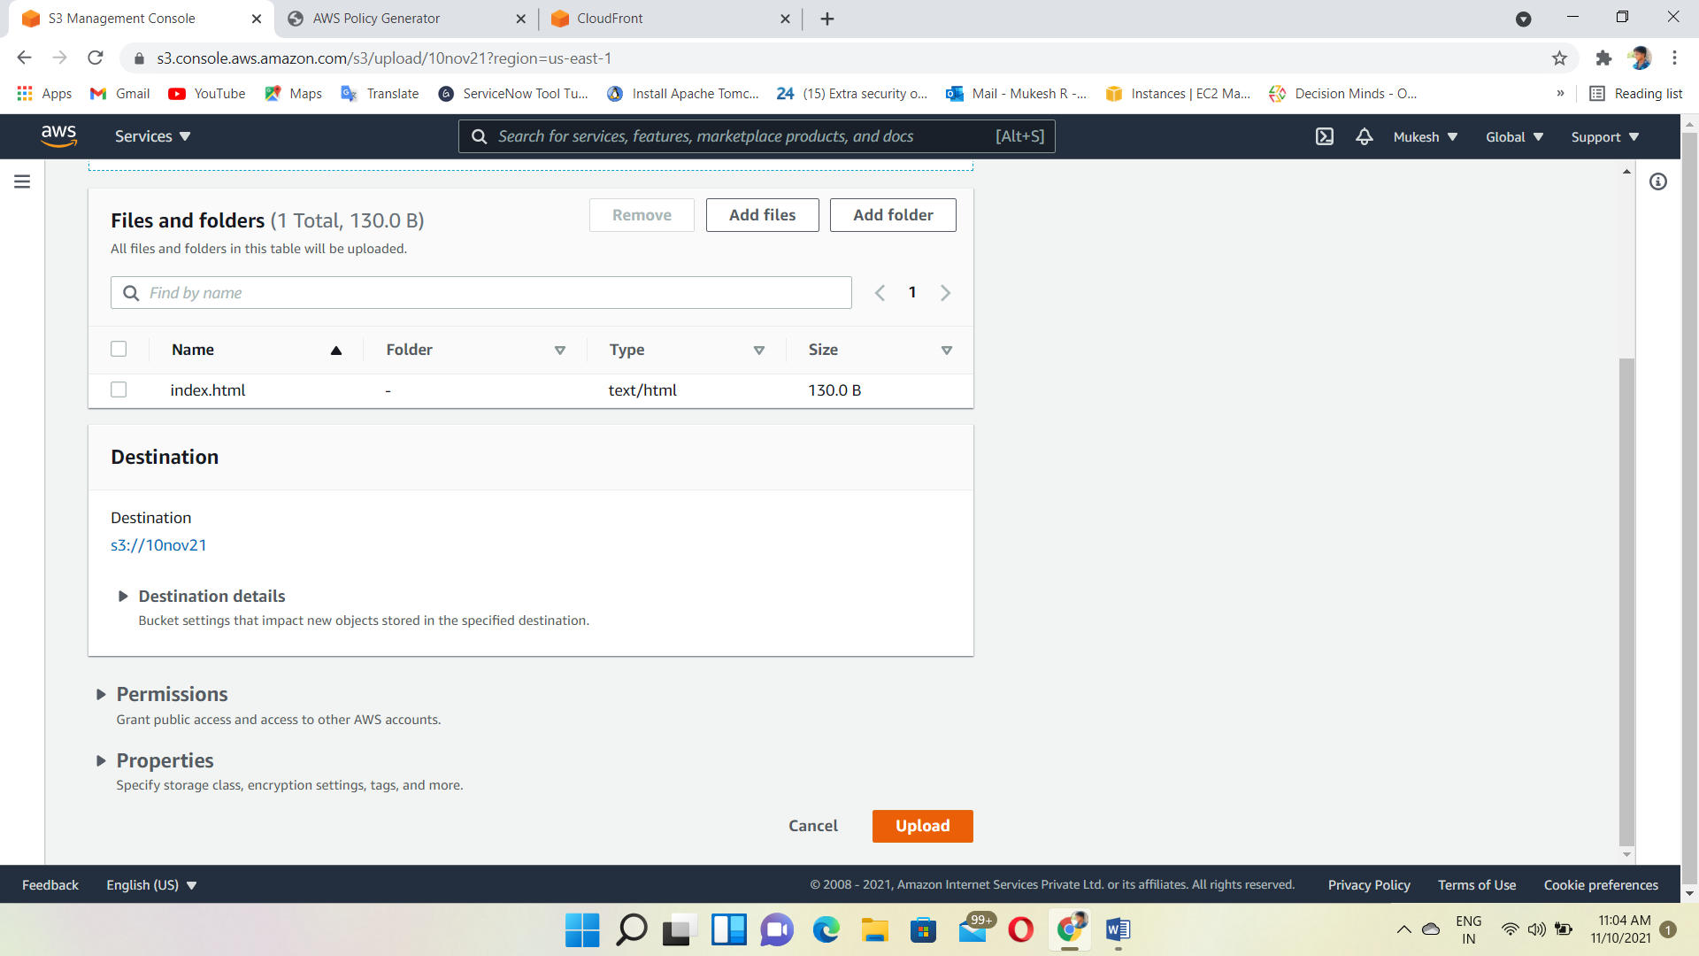

Edit the static website hosting

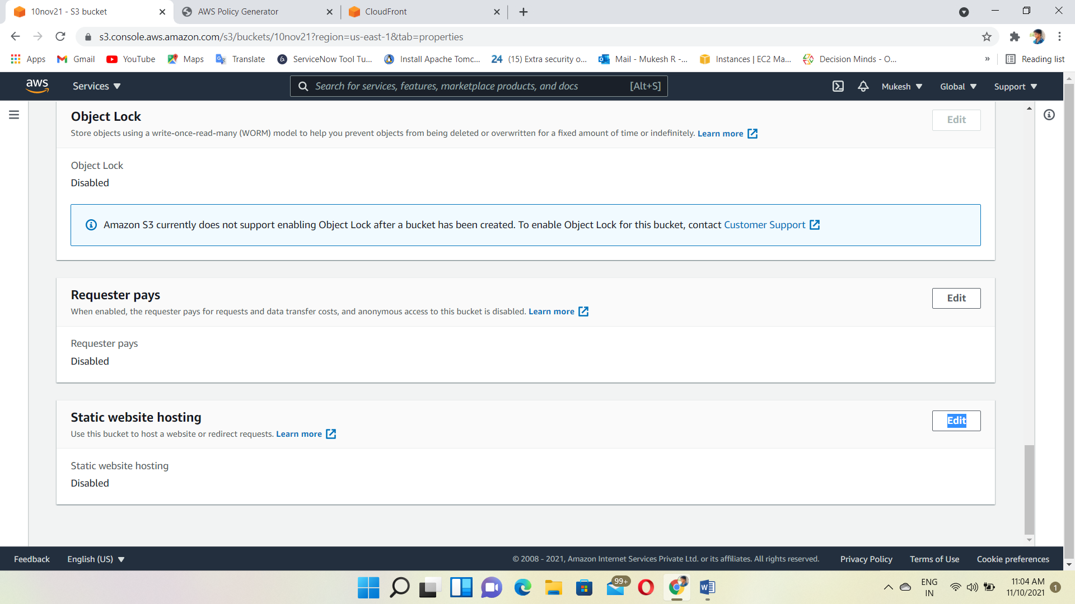

Enabling the static web host and entered the document type also

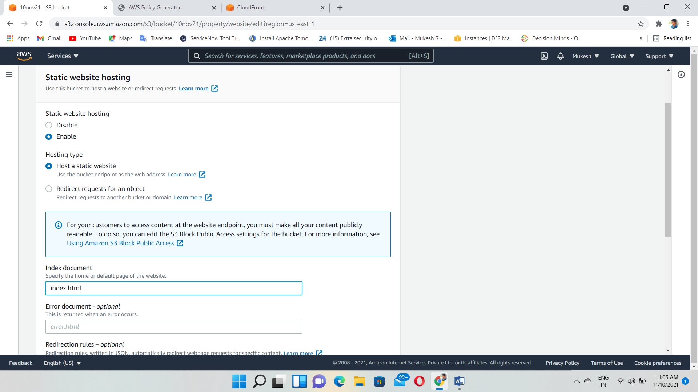

Copy that link

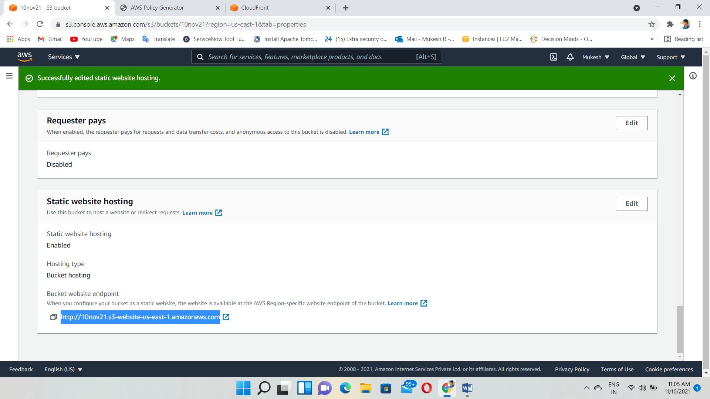

Browse that link and now, anyone view the html file through website

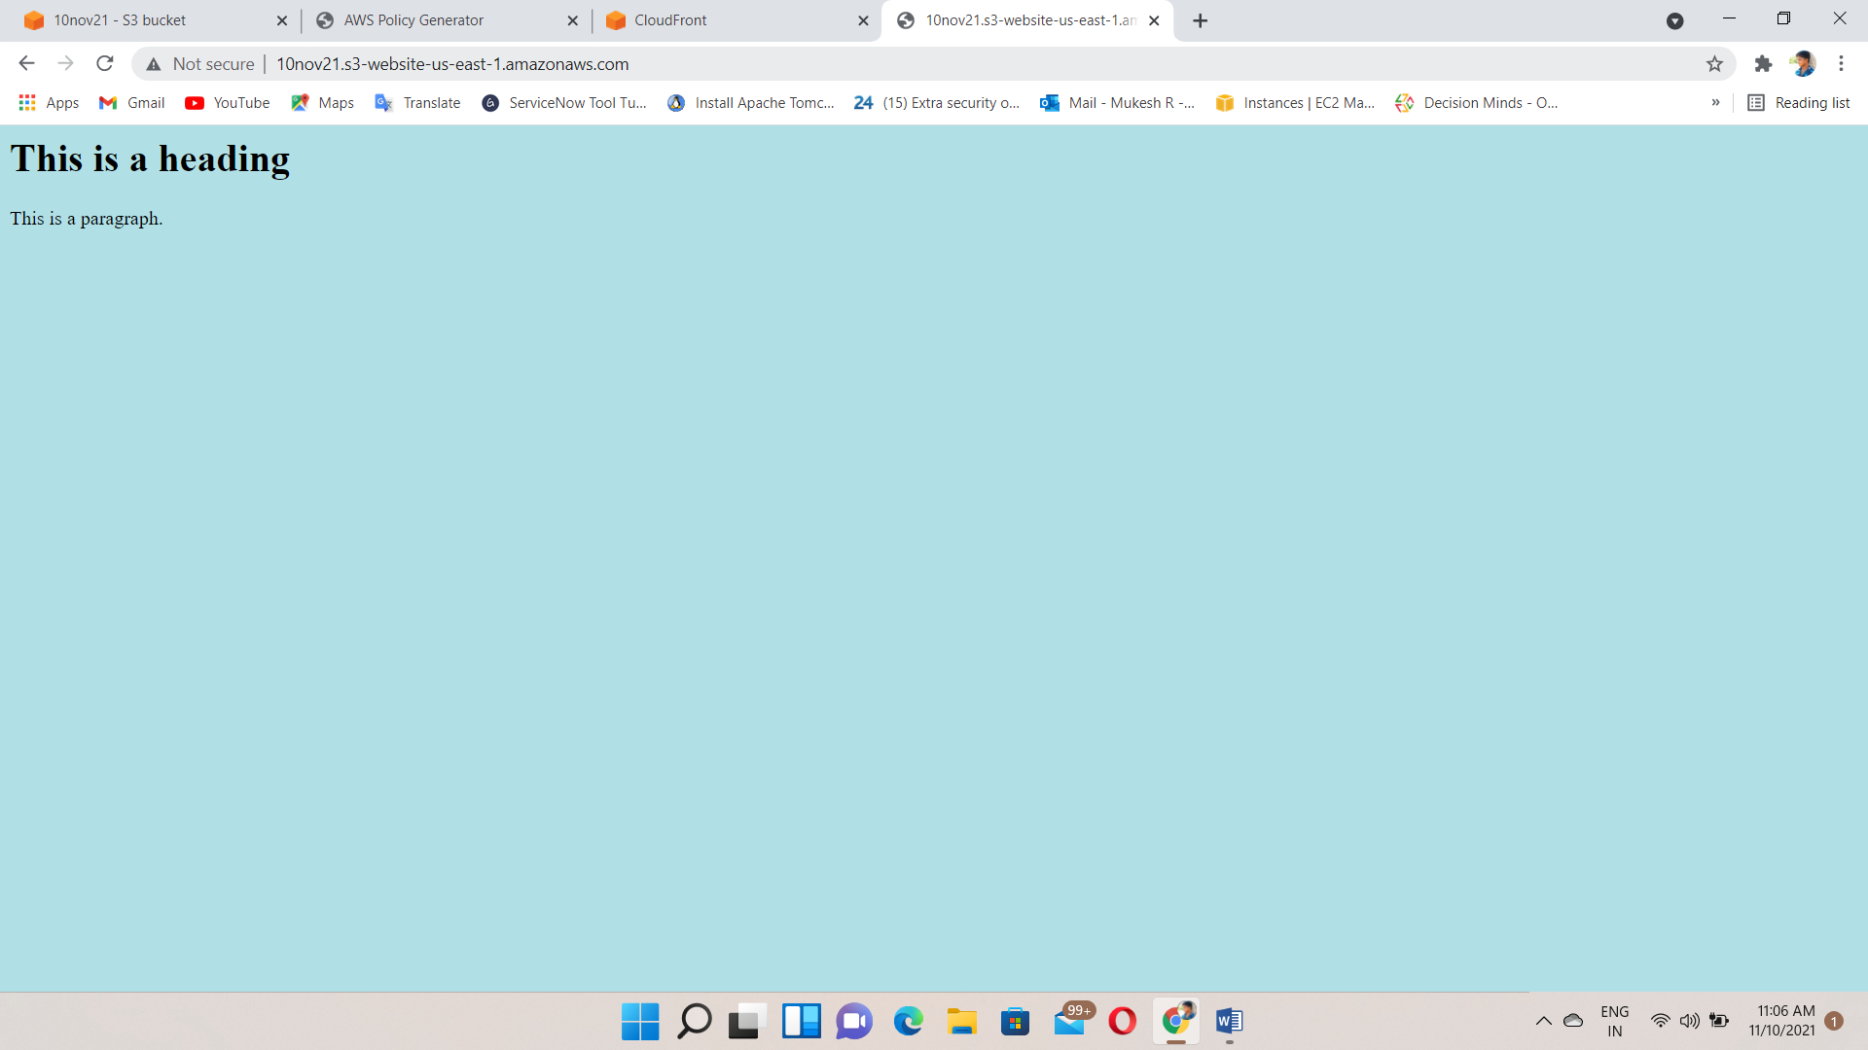

Go to Cloud front and create distribution

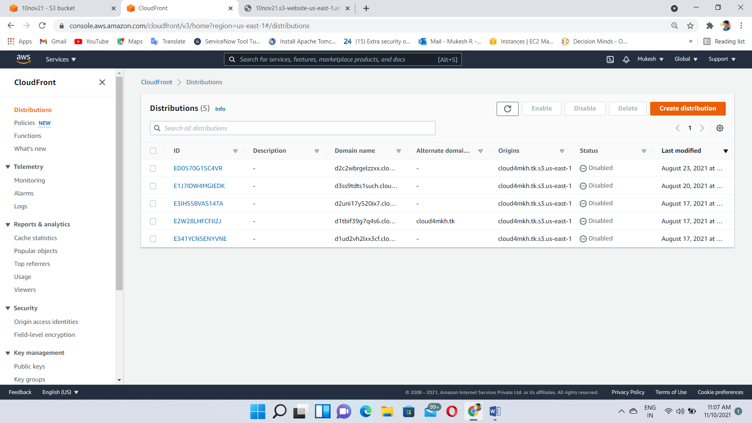

Give the origin domain of s3 bucket

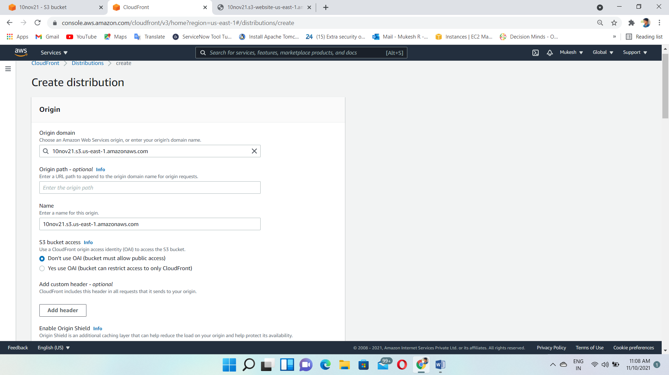

Create distribution

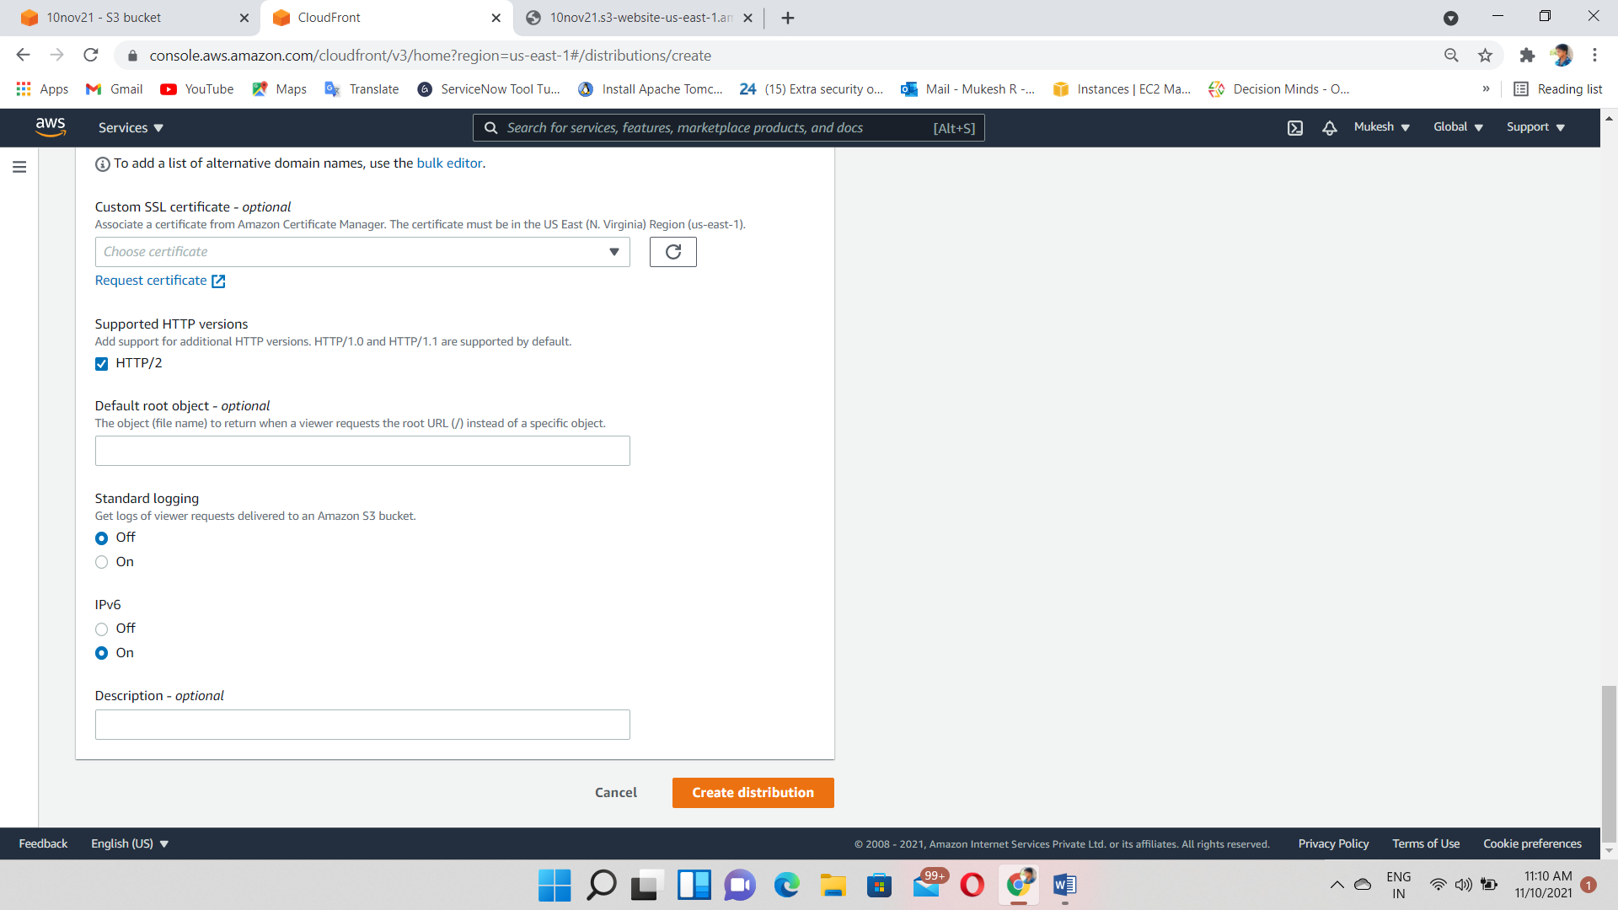

Copy the distribution domain name

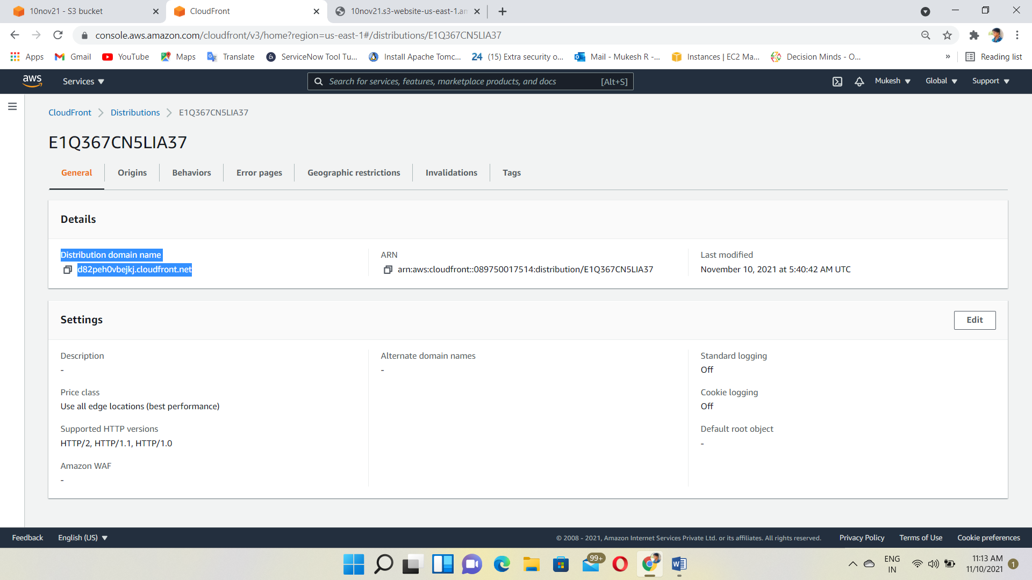

Paste it browser with /filename

Output: Finally, we got the web content faster than s3 web hosting

